Name: **ZOHAIB HASSAN SOOMRO**

RollNo#: **19SW42**

Subject: **DBS**



1. Create a table named BOOKS that will have 4 columns as:
   1. Book_ID with NUMBER data type. (Also PK)
   2. Book_Name with varchar data type and length 30.
   3. Author_Name with varchar data type and length 20.
   4. Book_Isbn with varchar data type and length 30.

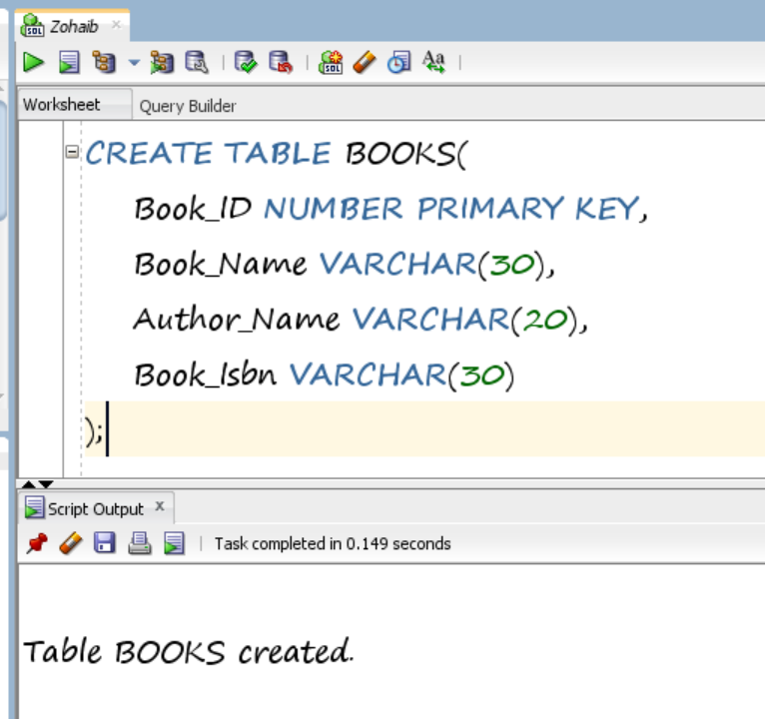

1. Modify the table created in the previous step by adding two new columns (related to the category of books) of your choice.

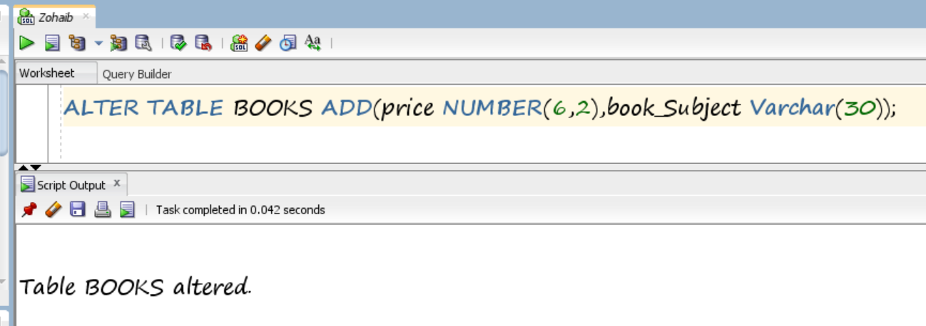

1. Insert 5 rows of records in the table created in question number 1. Display the data.

**Inserting Data:**

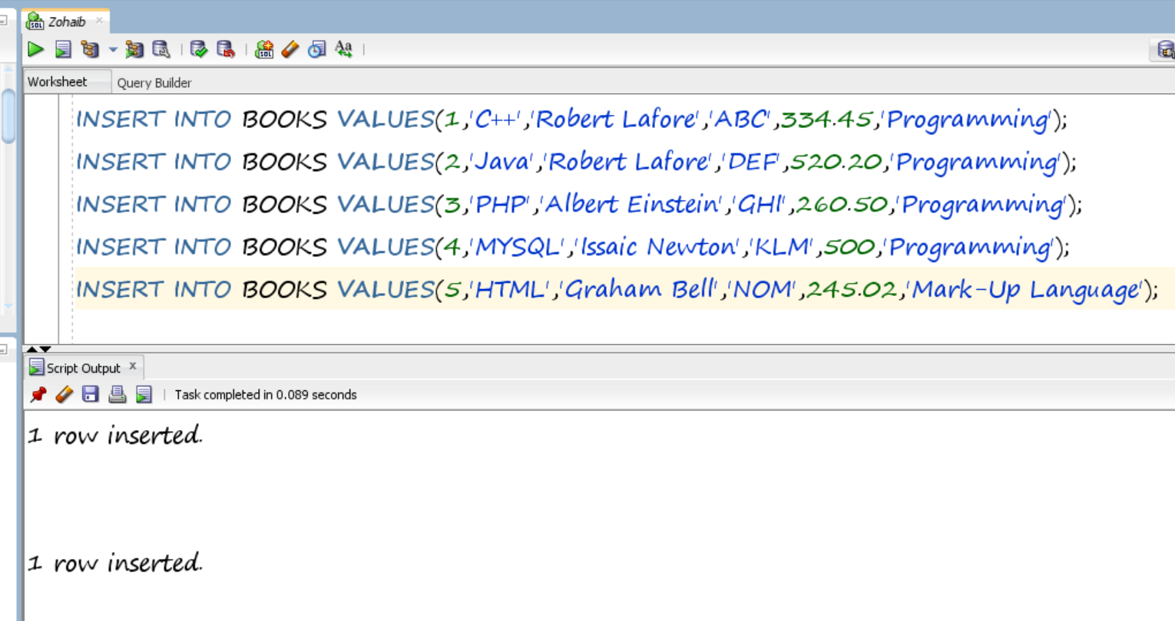

**Displaying Data:**

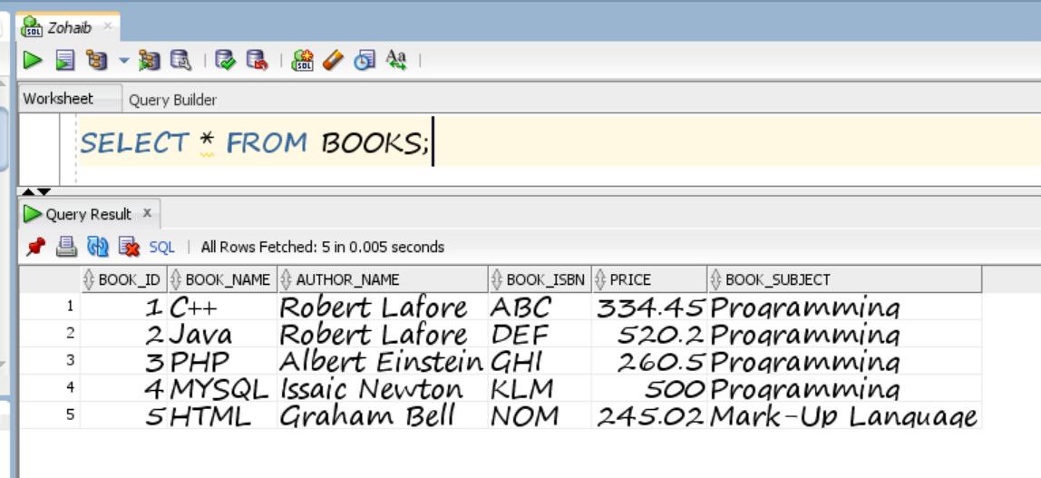

1. Modify the table created in question 1 by deleting one of the newly created columns.

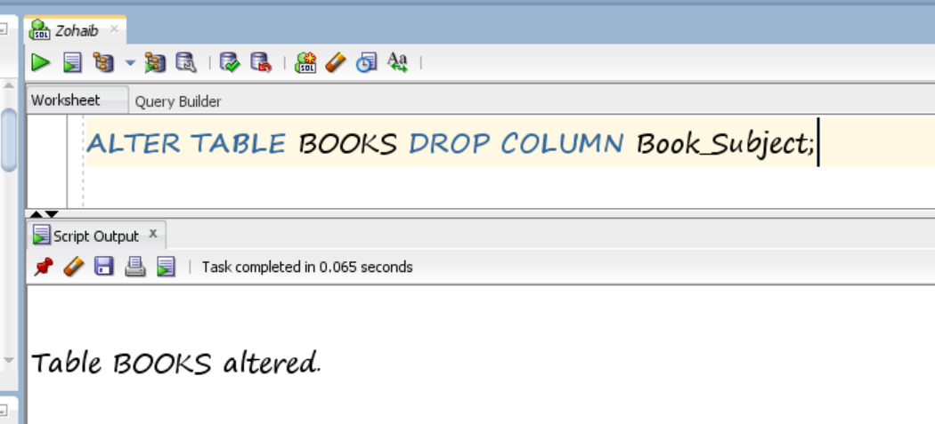

1. Truncate the table BOOKS. Display the output. Finally drop the table.

**Truncating Table:**

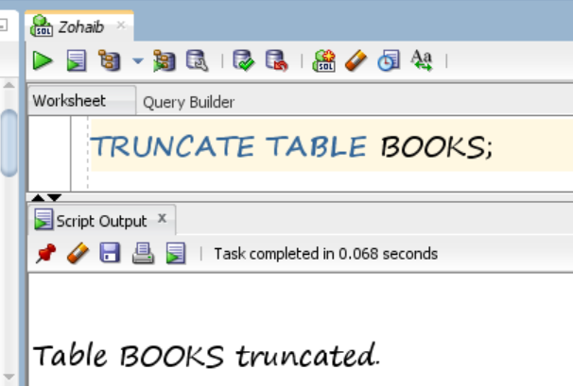

**Displaying Output:**

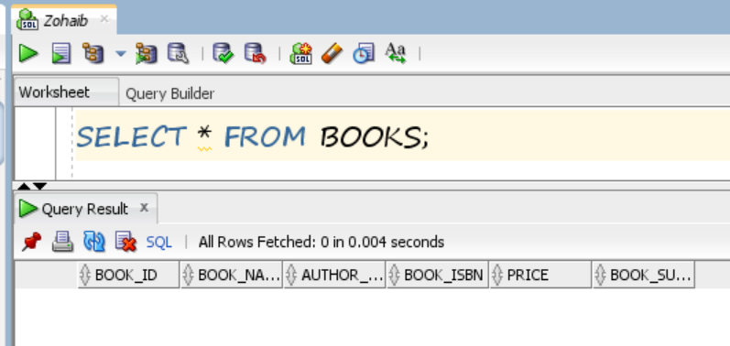

**Dropping Table BOOKS:**

